CHANDRALEKHA CHILUMULA

101745900

542-01

**DATABASE MANAGEMENT SYSTEMS**

**HOMEWORK ASSIGNMENT #3**

**Using SQL with ORACLE**

1. List the last name and address of managers who have a dependent with the same first name as themselves.

Ans. select lname, address from employee, department, dependent where ssn=mgrssn and essn=mgrssn and fname=dependent_name;

Screenshot:

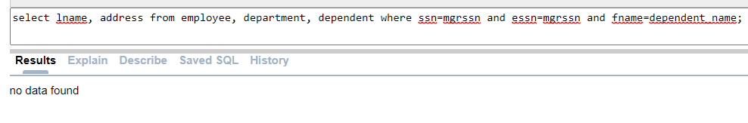

1. Retrieve the names of all employees who are directly supervised by ‘Franklin Wong’.

Ans. select fname, minit, lname from employee where superssn = (select ssn from employee where fname='Franklin' and lname='Wong');

Screenshot:

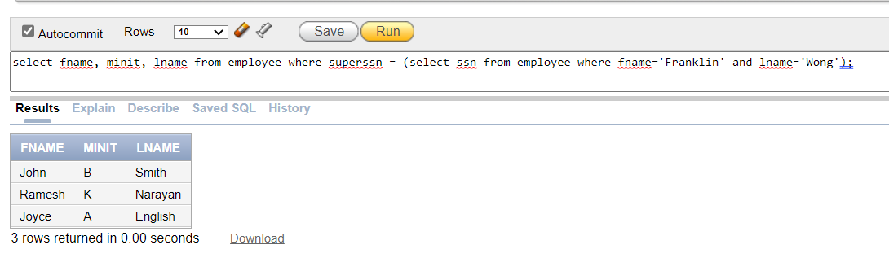

1. Retrieve the names of employees in the Research department who work more than 20 hours per week on the 'Computerization' project.

Ans. select fname, minit, lname from employee, department, project, works_on where dname='Research' and dno=dnumber and ssn=essn and pno=pnumber and dno=dnum and hours>20 and pname='Computerization';

Screenshot:

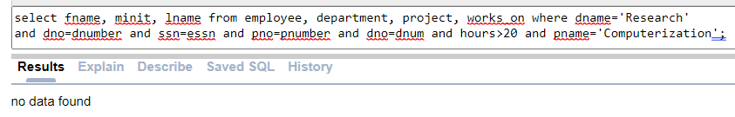

1. List the last names of all supervisors who have no dependents.

Ans. select lname from employee, department where mgrssn is null and dno=dnumber and NOT EXISTS (select * from dependent where mgrssn=essn);

Screenshot:

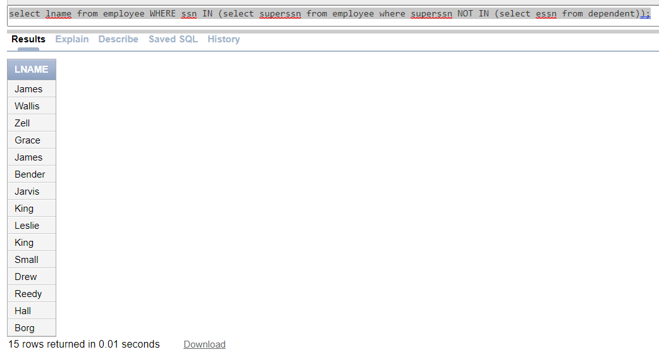

1. For each department, retrieve the department name and the minimum salary for all employees working in that department.

Ans. select dname, min(salary) from employee, department where dno=dnumber group by dname, dnumber;

Screenshot:

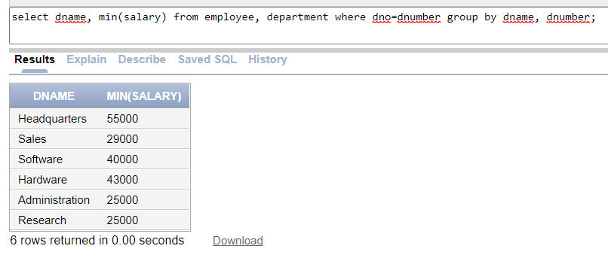

1. For each department whose average employee salary is more than $30,000, retrieve the department name and the number of employees working for that department.

Ans. select dname, count(ssn) from employee, department where dno=dnumber group by dname, dnumber having avg(salary)>30000;

Screenshot:

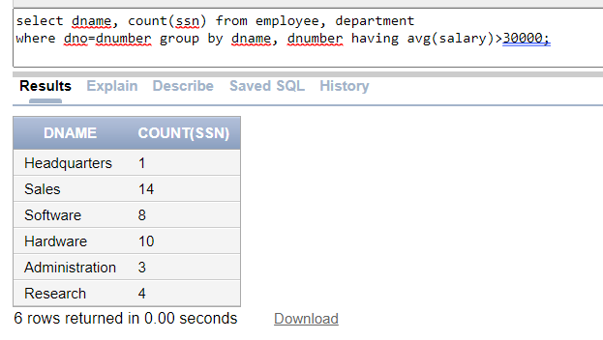

1. Retrieve the average salary of female employees who work more than 20 hours on projects.

Ans. select avg(salary) from employee, works_on, project where sex='F' and ssn=essn and hours>20 and pno=pnumber and dno=dnum;

Screenshot:

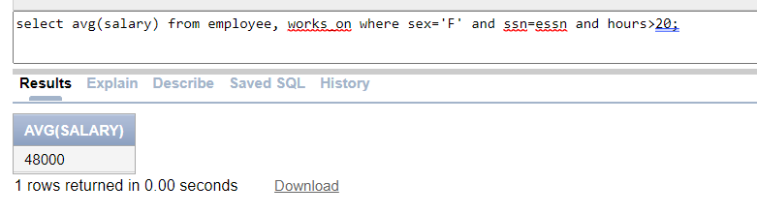

1. Retrieve the names of employees who work on every project that John Smith works on.

Ans. select distinct fname, minit, lname from employee, works_on where ssn=essn and pno IN (select pno from employee e, works_on w where e.ssn=w.essn and e.fname='John' and e.lname='Smith' INTERSECT select pno from employee e,works_on w where e.ssn=w.essn);

Screenshot:

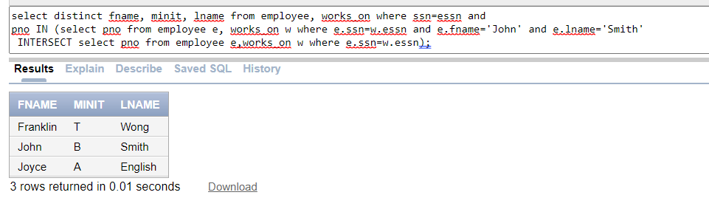

1. Find the names and addresses of employees who work on at least one project located in Houston, but whose department has no location in Houston.

Ans. select distinct e.fname, e.minit, e.lname, e.address from employee e, works_on w, project p, dept_locations dl, department d where e.ssn=w.essn and w.pno=p.pnumber and p.plocation='Houston' and dl.dlocation!='Houston' and d.dnumber=p.dnum and p.dnum=dl.dnumber and dl.dnumber=d.dnumber;

Screenshot:

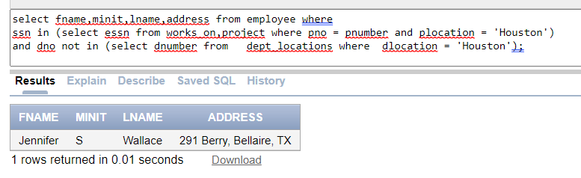

1. Create a view that has the employee name, supervisor name, and employee salary for each employee who works in the ‘Research’ department.

Ans. create view emp_details as select e1.fname as emp_fname, e1.minit as emp_initial, e1.lname as emp_lname, e2.fname as mgr_fname, e2.minit as mgr_initial, e2.lname as mgr_lname, e1.salary as salary from employee e1, employee e2, department d where d.dname='Research' and e1.superssn=e2.ssn and e1.dno=d.dnumber;

Screenshot:

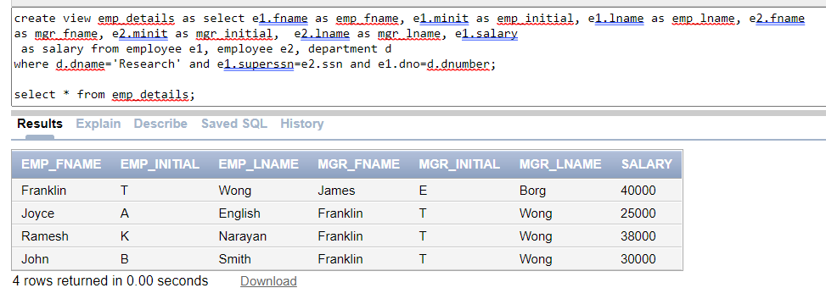

1. Create a view that has project name, controlling department number, number of employees, and total hours worked per week on the project (group by project name).

Ans. create view project_details as select pname as project_name, dnum as dnumber, count(ssn) as total_no_emp, sum(hours) as total_hours from employee, department, project, works_on where dnum=dnumber and pno=pnumber and essn=ssn group by pname, dnum;

Screenshot:

